Jyle Darling

M093437

CReating an installation package

AT1.5

Table of Contents

Creating the Installation Package 1

1. Create project 1

2. Enter Product Details 3

3. Add Installation Files 3

4. Define Java Products 4

5. Create program shortcut 5

6. Build 6

7. Run, test and remove 7

# Creating the Installation Package

For this project I have opted to use Advanced Installer to create the application installer package.

To get started I first downloaded the Advanced Installer from:

<https://www.advancedinstaller.com/downloading.html>

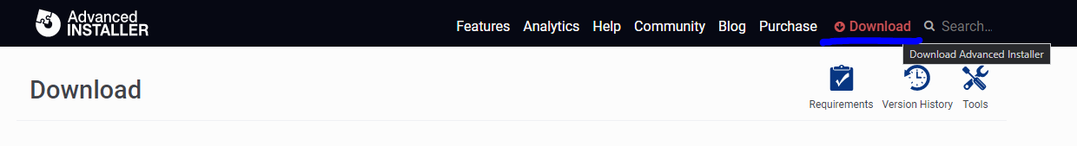

### 1. Create project

First you must have a java program that you wish to include in the installer package. Using NetBeans, creating a .JAR file is quite simple. On a finished project, right click on the project in the left menu, and select Clean and Build. 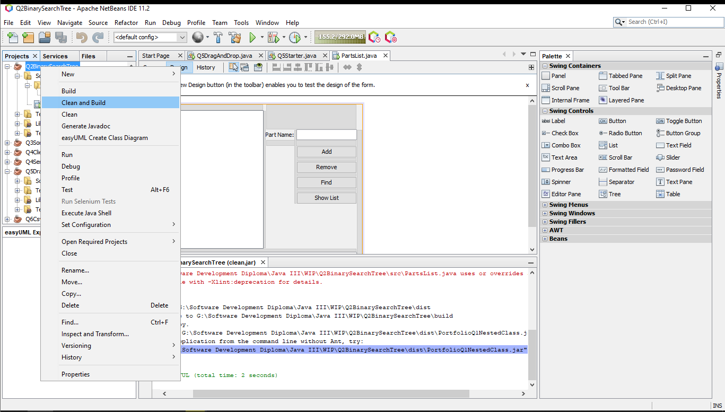

This will produce a File labelled dist within the project folder, which contains the new .JAR file. NetBeans also creates the .MF file that contains any the path details for any libraries or classes used by the main class.

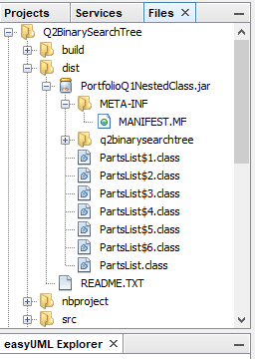

Let's say that we want to create a Windows Installer package for the Java Product. Start Advanced Installer and choose “Java” > “Java Application” as the project type.

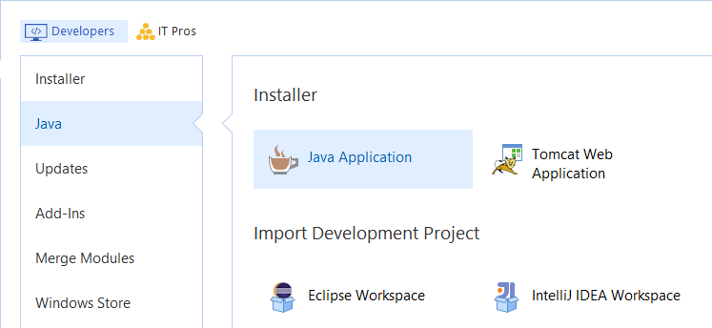

A good idea is to save and name the project at this point. Use the “Save” menu item under the “File” menu or the Ctrl+S keyboard shortcut and let's name it Q2BinarySearch.aip.

### 2. Enter Product Details

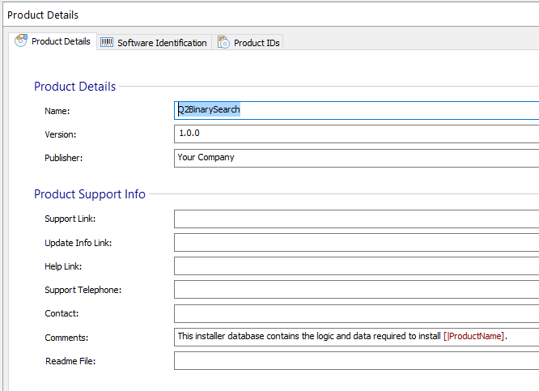

### 3. Add Installation Files

Go to the Files and Folders page by clicking on “Files and Folders” on the left side page menu.

Click on the [ Add File ] toolbar button. Browse to where your java application folder is located, then select Q2BinarySearch.jar file and click [ OK ].

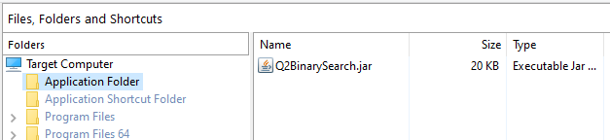

### 4. Define Java Products

Go to the Java Products page by clicking on “Java Products” on the left pane.

Create a new Java Product by clicking on the [ New Product ] toolbar button. Let's call it Java Product Q2.

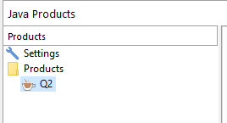

In the "Settings" tab, click on the [ Add JAR(s)... ] button and select the Q2BinarySearch.jar file and click OK.

Edit the Main class to: PartsList

Go to "Virtual Machine" tab and set the JVM parameters:

* Initial heap size - 64 Megabytes
* Maximum heap size - 256 Megabytes

Specify the JRE version min and max to whatever version you have installed on your machine.

You can set the parameters by clicking on [...] button from the JVM Parameters field this way accessing the Edit Java Virtual Machine Parameters Dialog.

Back in the "Settings" tab select GUI Application. Optionally set a splash screen for your java product.

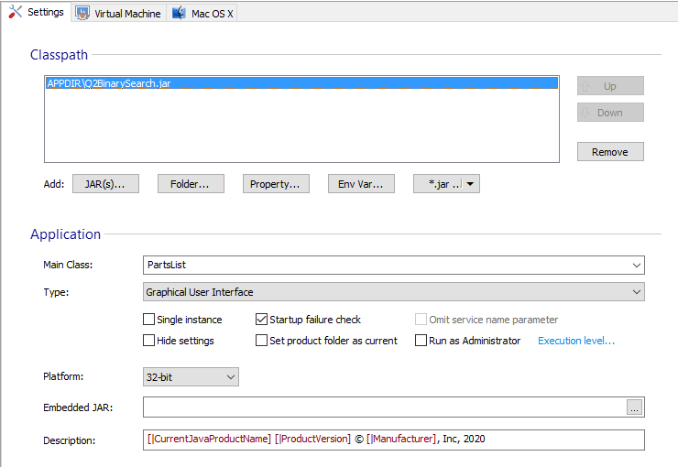

Now a new file has appeared in the Files and Folders Page: Java Product Example.exe.

### 5. Create program shortcut

Go to the Files and Folders page by clicking on “Files and Folders” on the left pane.

Select the Q2.exe file and click on the [ New Shortcut ] toolbar button. Set the description to: Q2 Binary Search Application. Find yourself a nice icon on your computer. Click OK.

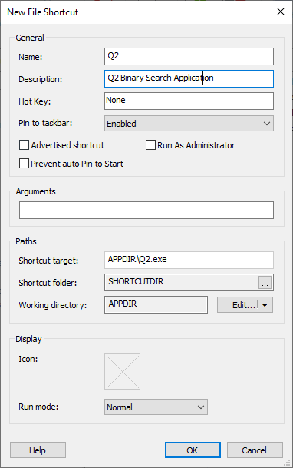

### 6. Build

Click on the [ Build ]  toolbar button.

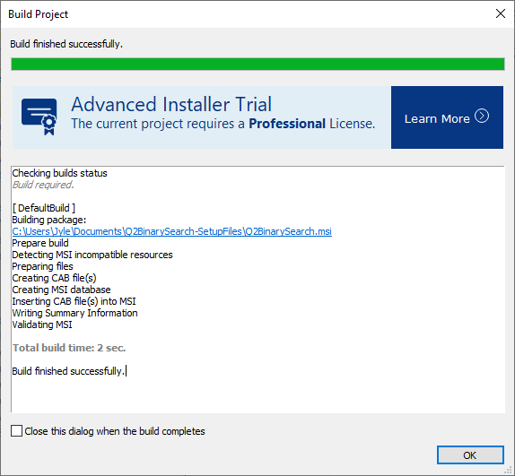

### 7. Run, test and remove

Click on the [ Run ] toolbar button to run and test the MSI you created. After installation you should have a Q2 Binary Search folder in your “Start” menu. Run the application by selecting Q2 Application.

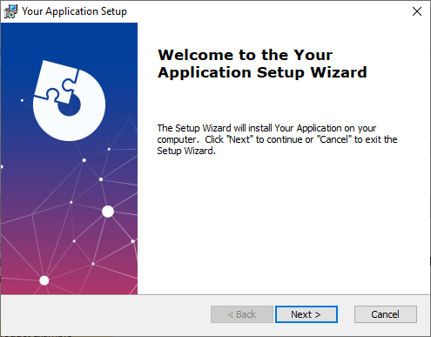

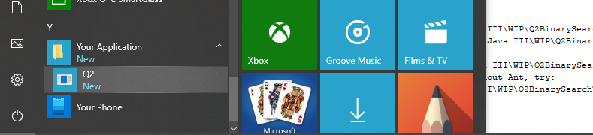

To remove the installed package, simply Run it again and select Remove.

